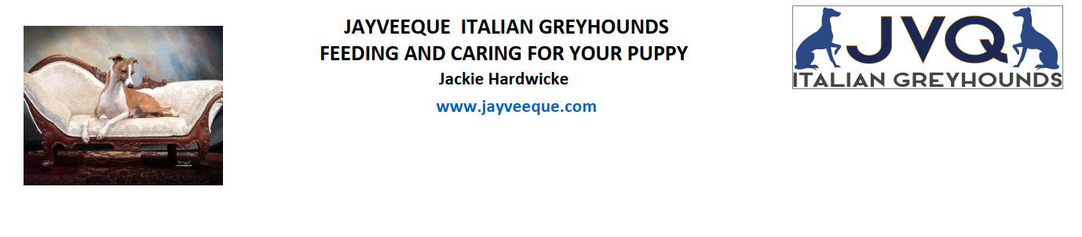
BREAKFAST AND DINNER ( 2 feeds per day up till 12 Month then once a Day)
Pro Plan / Royal Cannon Small or Mini Puppy,
As puppies I tend to ad lib, put about ½ cup in bowl and leave with them, replace every day with fresh in case
they have fowled.
AM and PM give about ½ cup of Prime 100 Chicken and Rice cut up finely, you can add some grated cheese
Alternately they do like My Dog, cooked chicken , mince meat cooked , again about ½ a cup
Monitor weigh you do not want to be able to see ribs or let them get too fat, as young puppies I tend to feed
them what they will eat and throw away anything left from feed before.
SNACK:
Pigs Ears or raw bones, do not feed cooked bones, dental chews are also a great idea as they help to keep teeth
clean and heathy

WORMING:
Your puppies has been wormed every 2 weeks up till now, you can now change to monthly up till 6 months an
Then move to 3 monthly.
PRODUCST TO USE: I would alternate between Milbamax and Drontal

HEARTWORM:
You will need to worm you puppy every month for heartworm (Milbamax or Advocate) , unless you get a yearly injection from your vet
FLEAS AND TICK:
We tend to use a topical product like Frontline or Advocate as some Italian greyhounds have a reaction to
Nexguard

