Caring for Teeth
Italian Greyhounds, like many other toy breeds, are notoriously prone to gum disease. Contributing factors are a long narrow skull with tight lips and a dry mouth. Dog saliva is alkaline and contains antibacterial enzymes. The normal bacterial flora which lives in the dog’s mouth helps keep harmful bacteria from flourishing(1) but not a lot of this will come into contact with the outer gum line. The IG’s tight lips will hold food particles against the gum line until it is removed by you.
This is not a Show Dog versus Pet Dog grooming issue nor is it fanatical over‐attention to your dog’s needs. It’s a serious health issue with this breed which you should be willing to take responsibility for on a daily basis. (Inflammation of the gums was listed as the most common breed heath problem in the 1993 IGCA Health Survey) This knowledge might convince you that an IG isn’t really the breed for you or help you to set a reasonable limit to the number of IGs in your household. There is no magic number to this limit: Some people can’t manage to care for the teeth of one IG and some have no problem caring for the daily dental needs of 7‐10 IGs. (This number could be greater but I haven’t yet met that individual.) A responsible breeder or rescue rep should not only stress the importance of daily dental care but be able and willing to teach you how to properly brush your dog’s teeth and train your dog to accept brushing. They should be providing follow‐up counsel to be sure that you are comfortable with the procedure.
The general rule of thumb is this: Brush DAILY for excellent oral health. Brush every other day for only mediocre dental health. Brush every 3 days and you WILL get tartar formation. The first several times you miss a 3rd day of brushing the tartar won’t be visible but it will be forming and given time, it will darken.
Brush for a few minutes each day, alternating between MaxiGuard (or another unflavoured or mint flavor canine toothpaste) and, when necessary, a canine oral solution containing .12% chlorhexidine (an antibacterial agent) like Enzadent. When the mouth is perfectly healthy I recommend using only MaxiGuard daily. If you notice the beginning of a gum problem such as bleeding or inflammation or detachment, you can use the chlorhexidine solution daily (or as a periodic preventative measure where permanent recession is evident) until the problem subsides. Prolonged use of products containing chlorhexidine can cause yellowing of the teeth which would not be desirable in a young show dog.
Yummy flavoured toothpaste only makes cleaning the teeth more difficult because the dog will want to lick more.
It’s best to use a small dog or cat toothbrush. Finger brushes & big dog tooth brushes are too large to get all the way to the very back teeth of an IG. Some people prefer dental wipes, which are great for young dogs, but I don’t believe they do as good a job between teeth, in crevasses or along the gum line. Some people swear by electric toothbrushes but be aware that it can be more difficult to train dogs to accept this and you need to be careful not to use so much pressure that you damage delicate gums.
Your local pet supply store might have what you need just be sure that the paste isn’t a “tasty” beef or poultry flavour. This will only encourage the dog to lick a lot, making efficient brushing more difficult. Mint flavour is not tasty to the dog and makes their breath fresher.
Be sure to use lukewarm water for rinsing the toothbrush.
Brushing should be done gently and with the confident and firm attitude of ‐ “I am not going to hurt you but we are going to do this” and thinking “don’t be silly this doesn’t hurt, now cut it out, this is important”. Your IG doesn’t have to love this procedure but must learn to accept it. It’s a fact of life. Be sure to PRAISE whenever the dog is behaving!
Begin these sessions when you have time to go slow but keep at it until you are finished. Do not attempt the training if you are feeling frustrated or impatient.
Start training your dog as adult teeth become fully erupted. Be aware that intensive and/or excessive mouth handling while the adult teeth are erupting and the puppy is teething is pointless and can create a dog that will always resent having its mouth handled. Gently lifting the lips and touching the gums of a young puppy is generally enough to have it accept later mouth handling. As the adult teeth become fully erupted you can start gently wiping them with a moistened gauze pad.
I don’t advise waiting for all of the adult teeth to be fully and completely in before starting dental care because I have seen several IGs that had to have adult incisors pulled at one year of age. These dogs didn’t have “genetically bad teeth” unless you think that the genetic structure that defines a pretty and houndy IG head is bad. Certainly some IGs seem to have teeth that you can neglect a bit longer since their teeth may be less crowded and in larger skulls but all IGs will benefit from daily attention to dental hygiene. If you don’t want a breed that requires this level of attention you might be better off with a breed that has a head like a Fox Terrier.
This structural propensity to gum disease is not to be confused with the very real problem of enamel hypoplasia that has been seen in IGs. Enamel hypoplasia(2) is a defect in the enamel that usually occurs during tooth development. Formation of the dental enamel is disrupted, leading to inadequate or absent mineralization of the dental enamel. Causes can be due to a number of issues occurring while the teeth are developing, such as: distemper, trauma and inflammation of the permanent tooth bud, systemic infections, massive parasite infection, endocrine problems and excessive fluoride in the drinking water. This leaves the enamel weak and pitied, causing rapid dental wear and yellowing and even greater propensity to tartar build‐up. Full dental restoration or bi‐yearly dental sealant may be applied. The critical need for daily brushing is further amplified by the presence of this condition.
Brushing while the dog is in a prone position will not only be easier, but will help with training your dog to accept a standing dental. I do the dog’s nails while they are prone for this same reason.
Part of the key to success is learning to restrain your dog in such a way that he can’t get loose from your firm grip. Dog that are allowed to flail and/or get loose are more inclined to build up a certain level of hysteria and/or determination to struggle. Think of a native American infant in a papoose: keeping them held snugly will give them a sense of security and keep them calmer!
To get your dog down on his/her side in the first place, hold the dog firmly against your chest and lower the dog to your side (or lap) while still against your chest. Once the dog is completely down (sandwiched between your side, or lap, and chest) put your hand on his shoulder and lift your body away from the dog.
Standing (anesthesia‐free) dentals should be done as needed but not as a substitute for daily brushing. Studies have shown that manually removing plaque daily with a brush is the best way to keep your dog’s gums healthy.(3) Monthly or bi‐monthly scaling instead of brushing gives you a false sense of security because, while the teeth may look reasonable or even perfectly lovely, it just isn’t healthy for the gums, roots and jaw bone to have bacteria routinely siting along the gum line. You might get away with this for a while, but as the dog gets older it will start to lose its teeth, and with increasing speed as the dog ages. If you notice inflamed or receding gums (commonly on the front teeth) or an unpleasant odor (bad breath is NOT normal) go to your vet and have the mouth checked thoroughly.
I’m not suggesting that you should avoid an anesthesia dental when necessary but it is foolish and costly to normalize yearly anesthesia dentals to avoid the responsibility of daily teeth brushing. Most vets won’t want to knock out a dog with anesthesia for minor tartar accumulation anyway. Working with someone capable of performing a standing dental will not only get the teeth clean before they become a problem but can help point out areas that you aren’t brushing well enough.
Few vets are willing to deal with standing dentals. It requires great patience and a certain amount of natural talent to scale a dogs teeth while they are awake. It’s not just something you can learn by taking a class. Not only is it an impossible procedure for many veterinary personnel to perform but cuts into clinic profit margins as well.
Several years ago a handful of people were getting a lot of press for having this patience and skill. Consequently a law was created to make scaling teeth at the gum line an Official Veterinary Procedure. This coincided nicely with advances in specialization of veterinary dentistry. (The Board Certified Specialist is specially trained to perform procedures such as periodontal surgery, root canal therapy and orthodontics.) Current law will allow for standing dentals to only be performed under the supervision of a veterinarian. Let your vet know that you would like them to at least be open to trying standing dentals. If you have developed the skill to keep your dog restrained for brushing ask that your vet to let you restrain your own dog while he/she scales the teeth. It can’t hurt to request that your vet try to find someone who could provide this service for their clinic.
You can ask your vet about using a stronger chlorhexidine solution for minor infections. Most vets will have 2% chlorhexidine gluconate concentrate on hand that can be diluted to .20% and applied to the gum line after brushing. You should apply this with a very fine syringe or a soaked Q‐tip. Avoid flushing the whole mouth as you want to discourage ingestion.
Scaling must always be followed by an application of polish to seal the enamel and prevent quicker plaque build up on a rough surface. Be sure that whoever is performing the dental is polishing as well!
If serious problems (such as loose teeth, extensive gum recession, serious plaque buildup on the inside of teeth, etc.) are going on, your dog will need to be put under anesthesia. If your dog is older and you are just learning to care properly for your dog’s teeth you might need to start your new dental regime after a thorough anesthesia dental.
Be sure to have your vet or canine dental hygienist examine your dog’s teeth and mouth thoroughly on a bi‐ yearly or yearly basis. As you become experienced at caring for your IG’s teeth you will be able to hold his mouth open for the vet as s/he exams the mouth. I mention this as I have been hearing with greater frequency about (dental specialists) vets who won’t do an oral exam unless the dog is anesthetized.
Bonuses of daily dental care include strengthening the bond you have with your dog and learning to detect early signs of oral disease which could be an indication of more serious impending health problems. It’s also very likely that your dog may NEVER need an anesthesia dental if brushing is done thoroughly and daily.
Dental chews and toys, hard biscuits and special dental diets can certainly help maintain optimum oral hygiene but should not be considered a reasonable substitute for daily teeth brushing.

Bibliography

Carson, DG and Giﬃn, JM: Dog Owner’s Home Veterinary Handbook. pg.147, 1987

Shipp, AD and Fahrenkrug, P: Practitioners’ Guide to Veterinary Dentistry. pg.76, 1992

Harvey, CE: Periodontal Disease; Diagnosis and Treatment. paragraph 4,1995

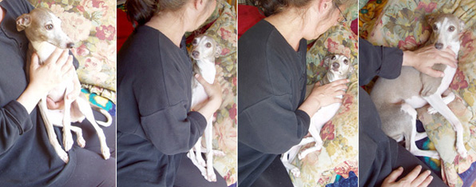
Since so many people seem to have a difficult time just getting their dogs down on their sides or backs I thought it would be a good idea to illustrate how to accomplish it.
It’s really quite easy. Start with the dog in your lap, against your chest. Keeping the dog pinned to your chest, lower the dog to the pillow at your side, bending your body to meet the pillow.
You will be pulling out your left arm that is behind the dog as you let the dog’s weight rest on the pillow. The dog will now be sandwiched between your chest and the pillow. Move your right hand to the dog’s shoulder to keep him in place.
Once the dog starts to relax you can raise your body away from the dog. Don’t try to sit up until the dog is resigned to staying put, then you use your left hand to keep the dog in place while you reach for the toothbrush.
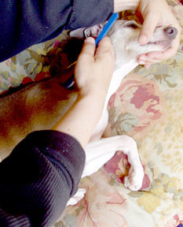This shows the dog in a proper prone position. Gently wagging the dog’s muzzle up and down for a bit can have a calming effect. Do this whenever you want to move the dog’s head if he is tense.
You use your right hand to brush and your right forearm to prevent the dog from shifting or geting away from you.
Use your left hand to hold the dog’s muzzle and control the head.
Until the dog is trained, and you are comfortable with your ability to restrain the dog, you should use a helper to place hands on the dog’s shoulder and thigh.

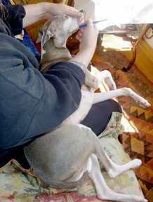This photograph illustrates a lap position of restraining your dog for brushing the teeth. Use a pillow at your side to extend the lap surface.

If the IG is smaller you can put the dog in your lap cradled between your legs with it’s head away from you, near your knees. I really like this position when I can prop up my feet on an ottoman.

More than half the battle is becoming skilled at really restraining your dog.
Every time they struggle and get loose they will be encouraged to escalate their efforts at “arguing” with you. With an IG, this can seem to be hysterics of operatic proportion. Don’t be discouraged by this type of performance.
Rather like a newborn infant, they will remain calmer if kept snug and and not allowed to flail.
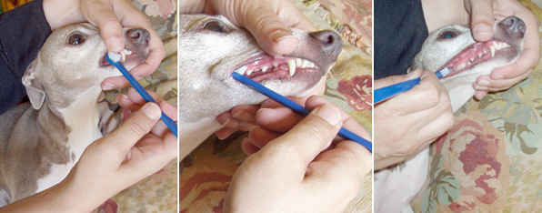
To get the brush into the side of the dog’s cheek you hold the head of the brush on it’s side and gently work it under the corner of the dog’s mouth. Always brush gently, but briskly, in a small circular motion.
Brush the upper and lower small teeth (called premolars),on the sides, between the canine teeth and molars, using your thumb and fingers to expose the gum line.
Move on to brushing the back upper molars.
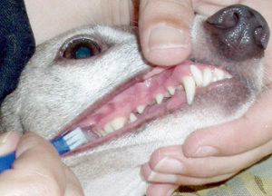At this point you should use the toothbrush to stretch the cheek away from the dog’s teeth so you can see just how far back the teeth.
As you dog gets conditioned to having it’s teeth brushed get into the habit of looking at each tooth carefully to inspect for plaque/tartar you might be missing or any signs of infection such as bleeding or inflamed gums.
Fortunately, this is extremely rare if you are being a 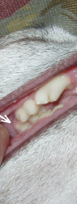pointed up and to the right)
You probably won’t see it by just pulling the cheek back. Try feeling for it with your finger or prop the mouth open and pull back the cheek as I have done for this photo.
I only the prop the mouth open and brush these teeth by feel. Do inspect these molars often as per directions above, to be sure you are brushing them thoroughly.
Some dogs figure out the trick of pulling the corner of their mouths back far enough (like a very forced grin) to get the toothbrush to pop out of their mouth.

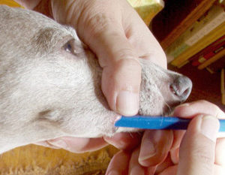To prevent this, use your thumb to stretch the upper lip towards the dog’s nose.
Notice how the brush (and teeth) go as far back as the hairy mole on the dog’s cheek.

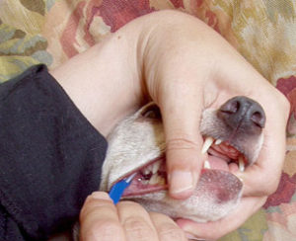With the mouth propped open you can now reach the rear most smallest molar that is behind the two large molars on top as well as have full access to the bottom molars and gum line.

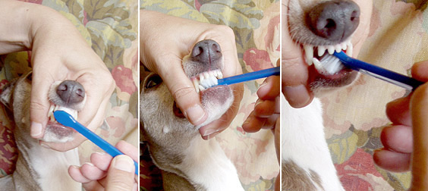
So long as I already have the mouth propped open I go ahead and brush the incisors (the small teeth in the front, between the canine teeth on top and bottom), inside and out.
Brush the insides of the premolars, top and bottom, when doing the insides of the incisors.
You will also do a better job on the lower canines on the outside when the mouth is open
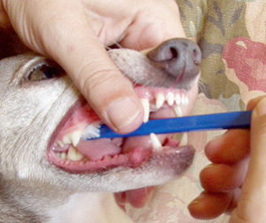Contrary to popular belief, most IGs will eventually get some tartar build up on the insides of their molars. I’ve seen some that actually got terrible recession on the insides of the upper molars.
You will want to have your dog fairly well conditioned to having the brushed before working on the inside of the molars.
The dog will feel like it’s gagging a bit, especially when doing the insides of the lower molars, so try to do this as calmly and quickly as possible
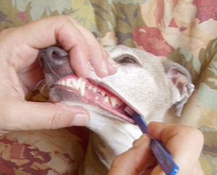Moving on to the left side of the dog’s mouth you will need to turn the dog’s head back to face you.
Don’t forget to wag the dogs muzzle gently if he is tense.
Note how the upper molars prevent access to the lower molars and lower gum line when the mouth is closed.

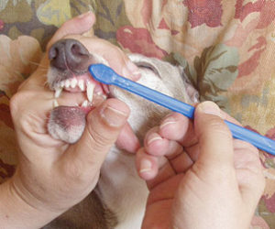Doing the back side of the head will feel a little awkward at first. You might want to experiment with different holding positions.

Do the teeth in whatever order you prefer so long as you are consistent and getting all surfaces thoroughly brushed.
How you end the procedure is very important too.
When finished with the teeth, scoop the dog back up to your arms, on your terms, meaning, you control this change of position, don’t let the dog do it.
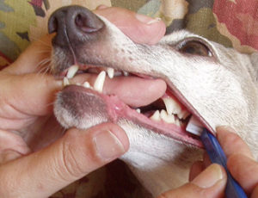Give some serious snugs and kisses and tell the dog how great he is. This should be the ultimate reward for his cooperation.
Before letting the dog go on it’s merry way, try laying back and letting the dog play at dominating you for a bit. Most dogs will get very frisky and smother you with kisses.
This is a sure sign that they really don’t resent your taking charge all that much.

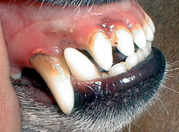 BEFORE
Example of typical tartar buildup on the canines and incisors of a 2.5 year old Italian Greyhound. (Left side of mouth)
This dog had the typically recommended care: teeth brushed once a week starting at one year of age and had an anesthesia dental done at 2 years of age.
This dog does NOT have defective enamel… just the typical head structure of an IG.
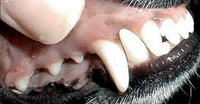AFTER.
PRETTY! This is the same dog’s canines and incisors after a standing dental and a couple of weeks of daily brushing.
Note the improved gum colour and how the inflammation has gone down.
Every IG deserves to have teeth maintained at this level of excellence!
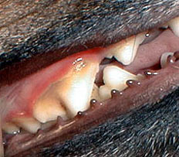 BEFORE
He is lucky that he has good teeth and dental enamel under all that gunk. Note the swelling and dark colour of the gums. This is the beginning of gum disease.

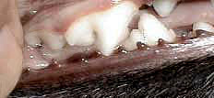AFTER.
Your dog’s teeth should look like this every day, not just the ﬁrst couple of weeks after a dental scaling!
Here is a senior IG turned into rescue by a loving but very ill 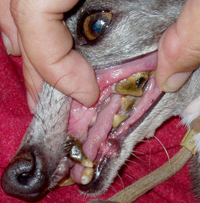owner.
Her dog’s breeder never told her that she should brush her IG’s teeth. (of course this same “person” wouldn’t return her calls when she asked for help re‐homing her dogs either)
She did ask her vet if there was anything she could do when she learned that her IG had enamel hypoplasia. He told her nothing would help, it was “just a problem of the breed”. The vet had her come in once a year for extractions.

Her molars were only held in place by “bridge‐work” of 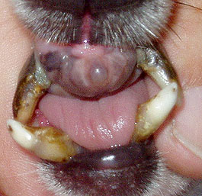tartar.
As I sat with her owner the day she brought her to me she started to cry when she saw how compliant her little girl was as I gently flushed rot from her mouth. She would have brushed her dog’s teeth if anyone had told her it was possible or would make a difference.
Her incisors were probably the first teeth she lost.

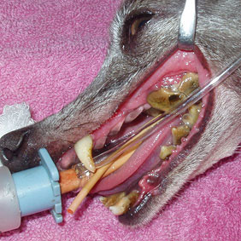One canine tooth was deemed salvageable

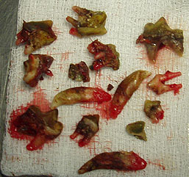All the rest of the teeth slipped out with litile effort.

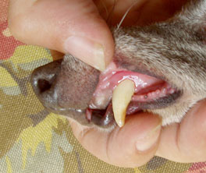Her sole remaining tooth: doing really quite well after two weeks of daily brushing and chlorhexidine treatment.
These teeth belong to an 8 year old Italian Greyhound whose owner and vet probably never thought to look in the poor thing’s mouth, that is, IF the dog ever HAD a visit to the vet!

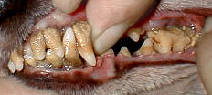Note how the tartar almost reaches the tips of the canine teeth.

